**Directions for making iPath Figures using proteomic data from Timmins-Schiffman et al. 2014**

This is a brief manual for submitting the raw data to generate more detailed and interactive maps identical to Figure S3 using iPath2.0. Raw data to input is included in the FigShare documentation.

Go to <http://pathways.embl.de/>   
Click on the image to select **iPath v 2: the main interface.**

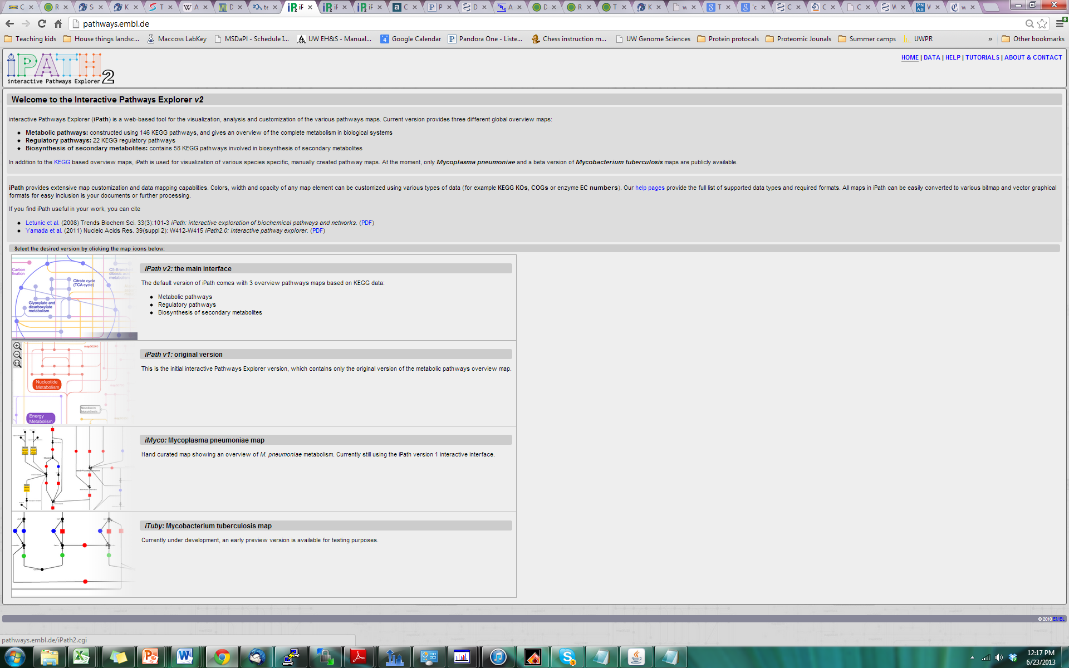  
On the upper right corner select "Customize"

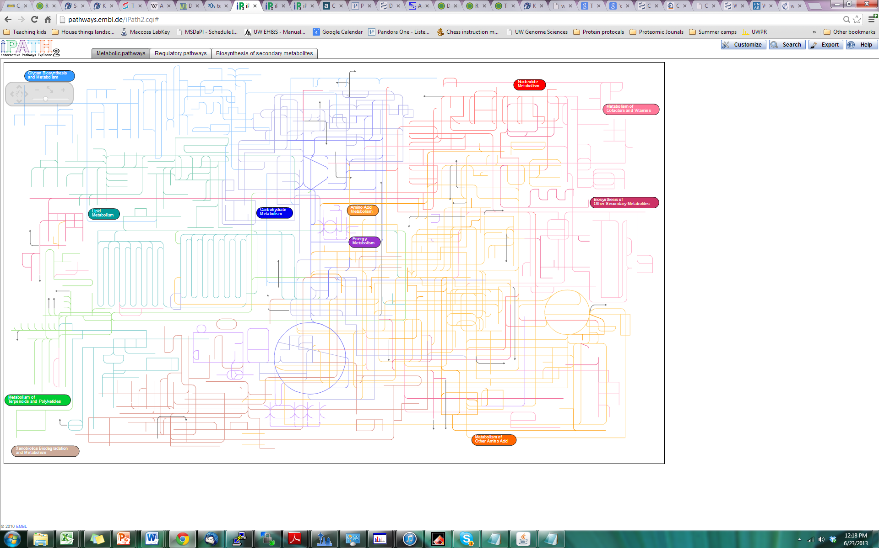  
  
This is where you can upload data to generate an iPath map   
You can provide a title to the plot by typing in the “Selection title” space

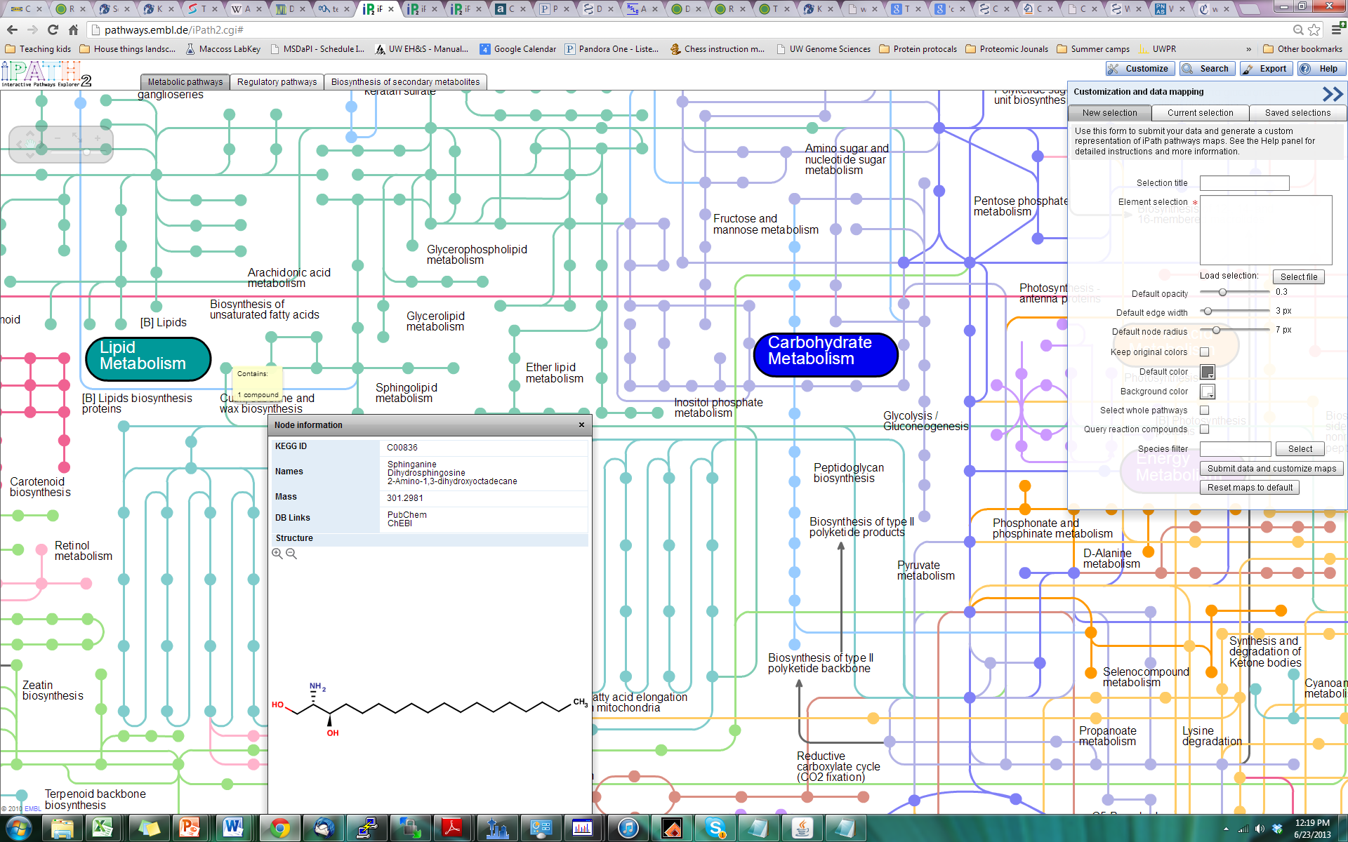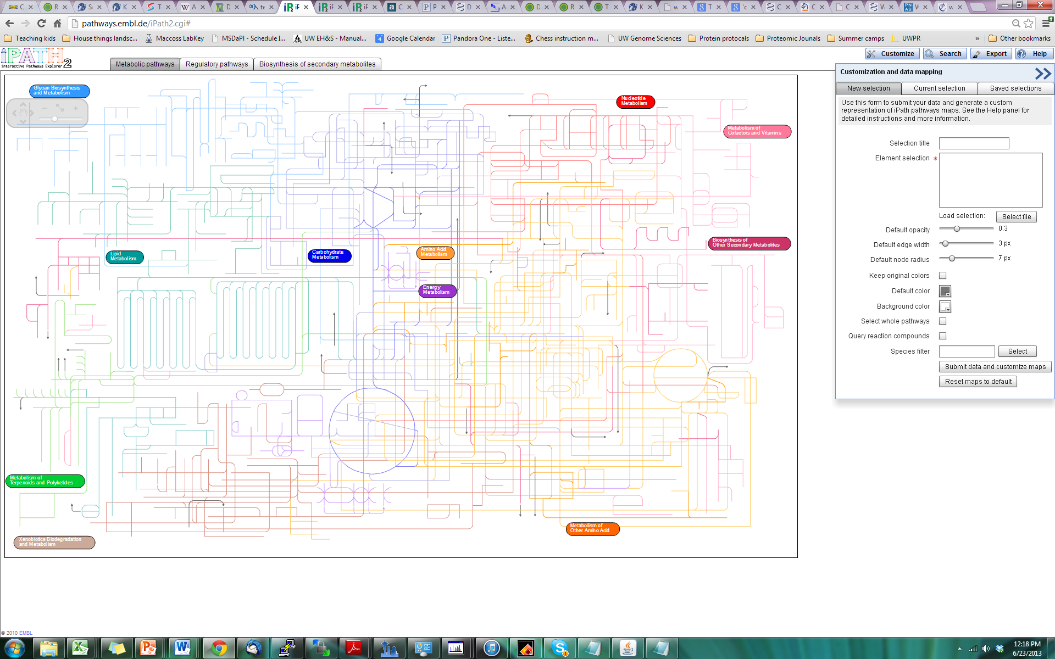  
Download the .txt files from FigShare. OA IPATH 2-fold is a list of proteins that are at least 2-fold differentially expressed in oyster gill tissue from the high vs. low pCO2 treatments; 400MechS IPATH 2-fold is differentially expressed proteins in oysters exposed to mechanical stimulation at 400 uatm vs. the control (400 uatm); 2800MechS IPATH 2-fold is differentially expressed proteins in oysters exposed to mechanical stimulation at 2800 uatm vs. 2800 uatm without further stress. By clicking “Select File” in iPath you can upload any of these files, or you can copy and paste their content into the “Element selection” box.

Click button for "Submit data and customize map". If you click “keep original colors” this will maintain the color-coded metabolic pathways in the map.  
You may need to wait about 20 seconds for the map to be generated.   
  
Now you can zoom in on the proteins identified that are present in the metabolic biochemistry map.  Each line represents an enzyme and the nodes represent compounds. The upper left-hand corner has a picture of a "+" and "-" sign to zoom in and out or you can select the hand to push the sheet of paper around to look at different areas while you are zoomed in.   
If you take your mouse pointer and hover over a line, you will see that a list of enzymes will be highlighted.  You can then select a specific identified enzyme to get more information on that protein. You can also select nodes (dots on the plot).  These dots represent different compounds that are synthesized by the enzyme that is represented by the line.